Cupcakes
Strawberry crunch cake
Birthday
Chocolate
Oreo
Reese
Boston Crème
Strawberry Pop Tart
Red Velvet Cake Pops
Much more….. Fruity Peebles
Oreos
Banana pudding
Strawberry
Chocolate
Much more…

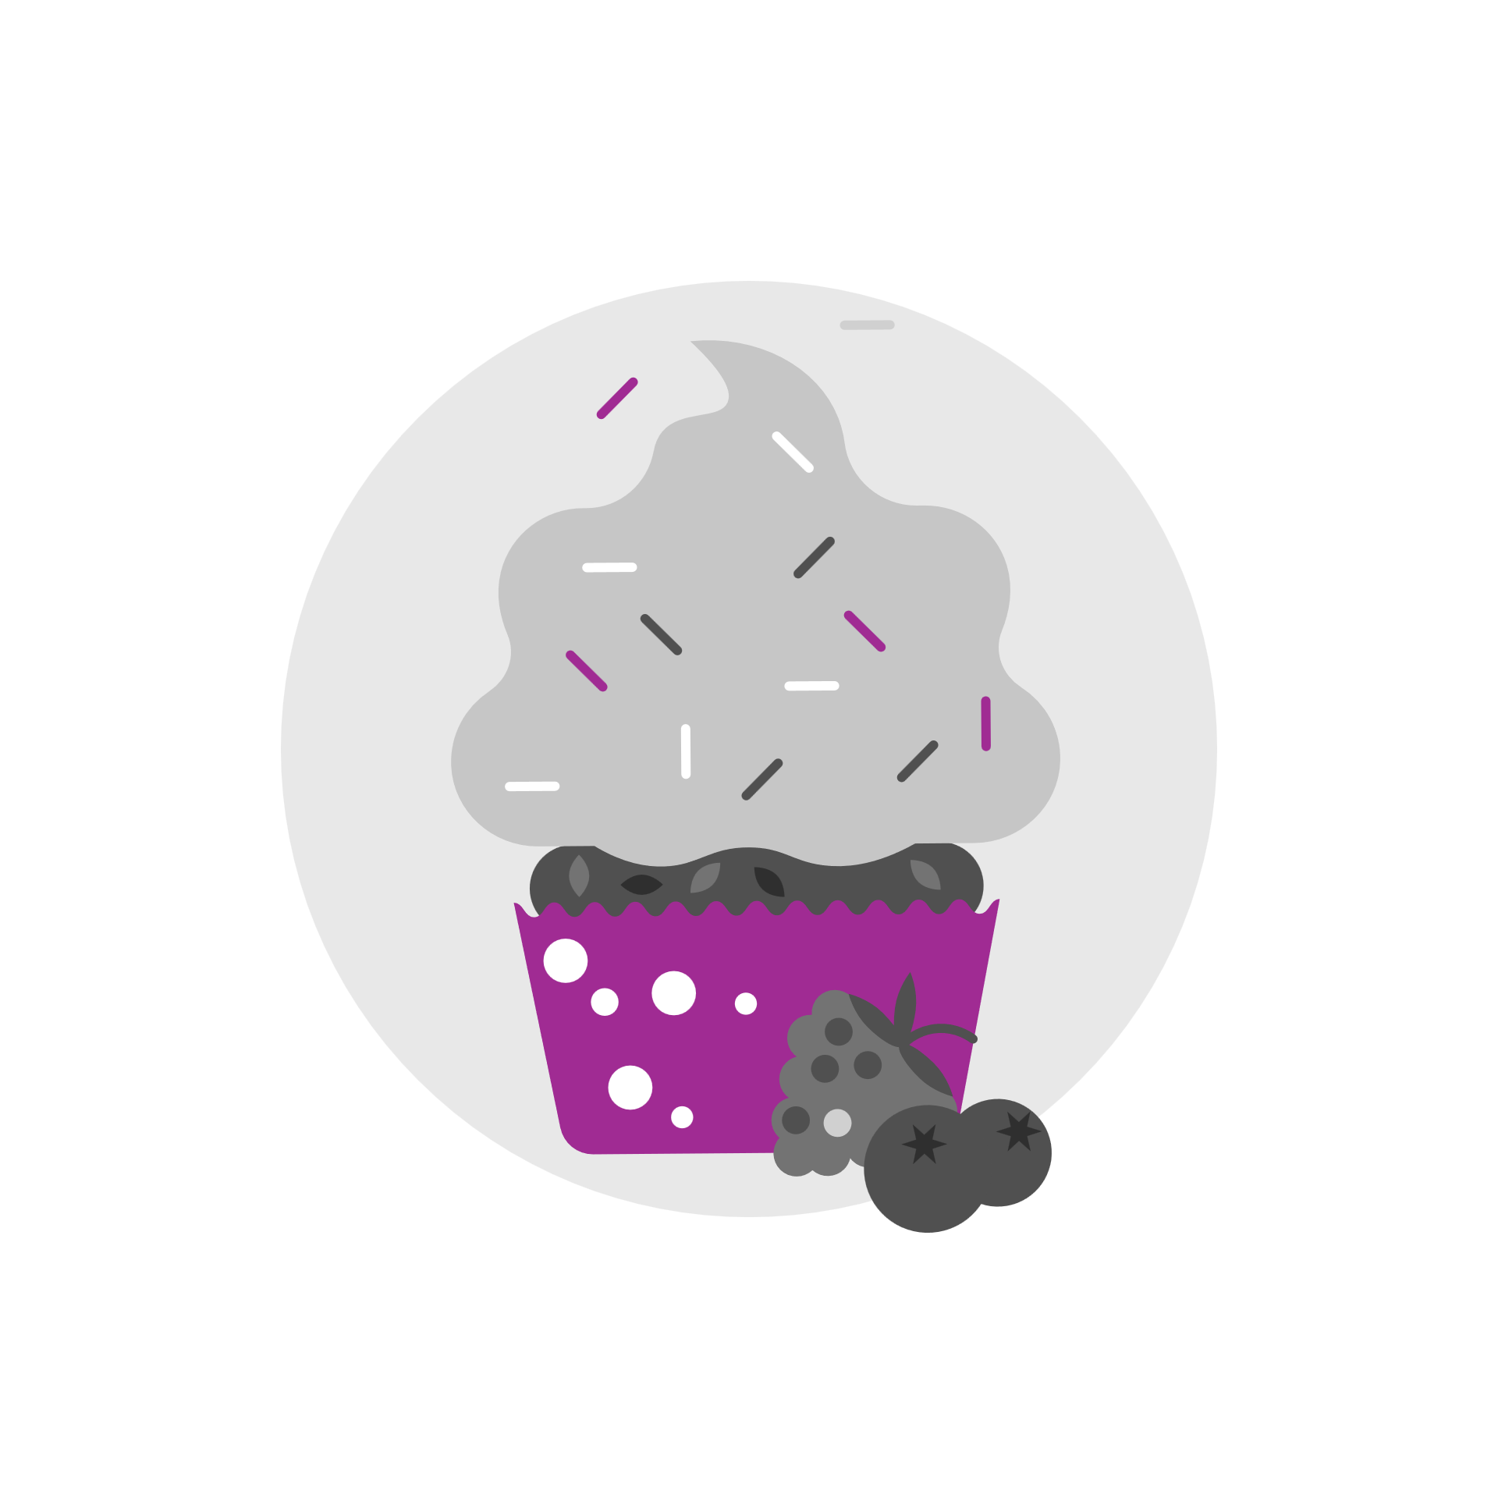
Chocolate Cover Oreos

Mini Cakes
Strawberry cheesecake crunch cake
Lemon Blueberry
Birthday cake
Cookie Monster
Carrot
Smores
Fruity Peebles
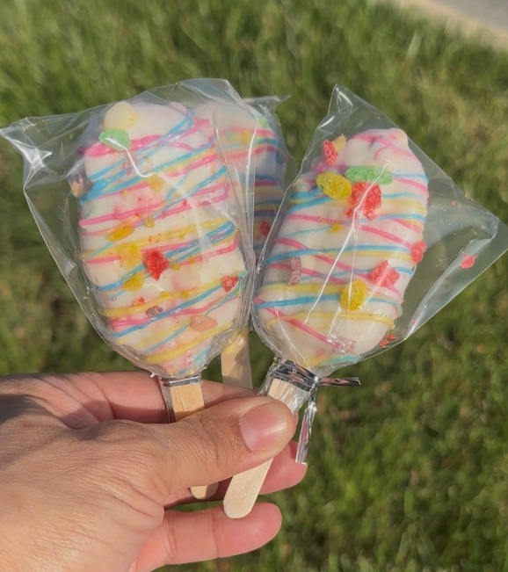
Much more…

